One Bridge  a concept in progress |  | 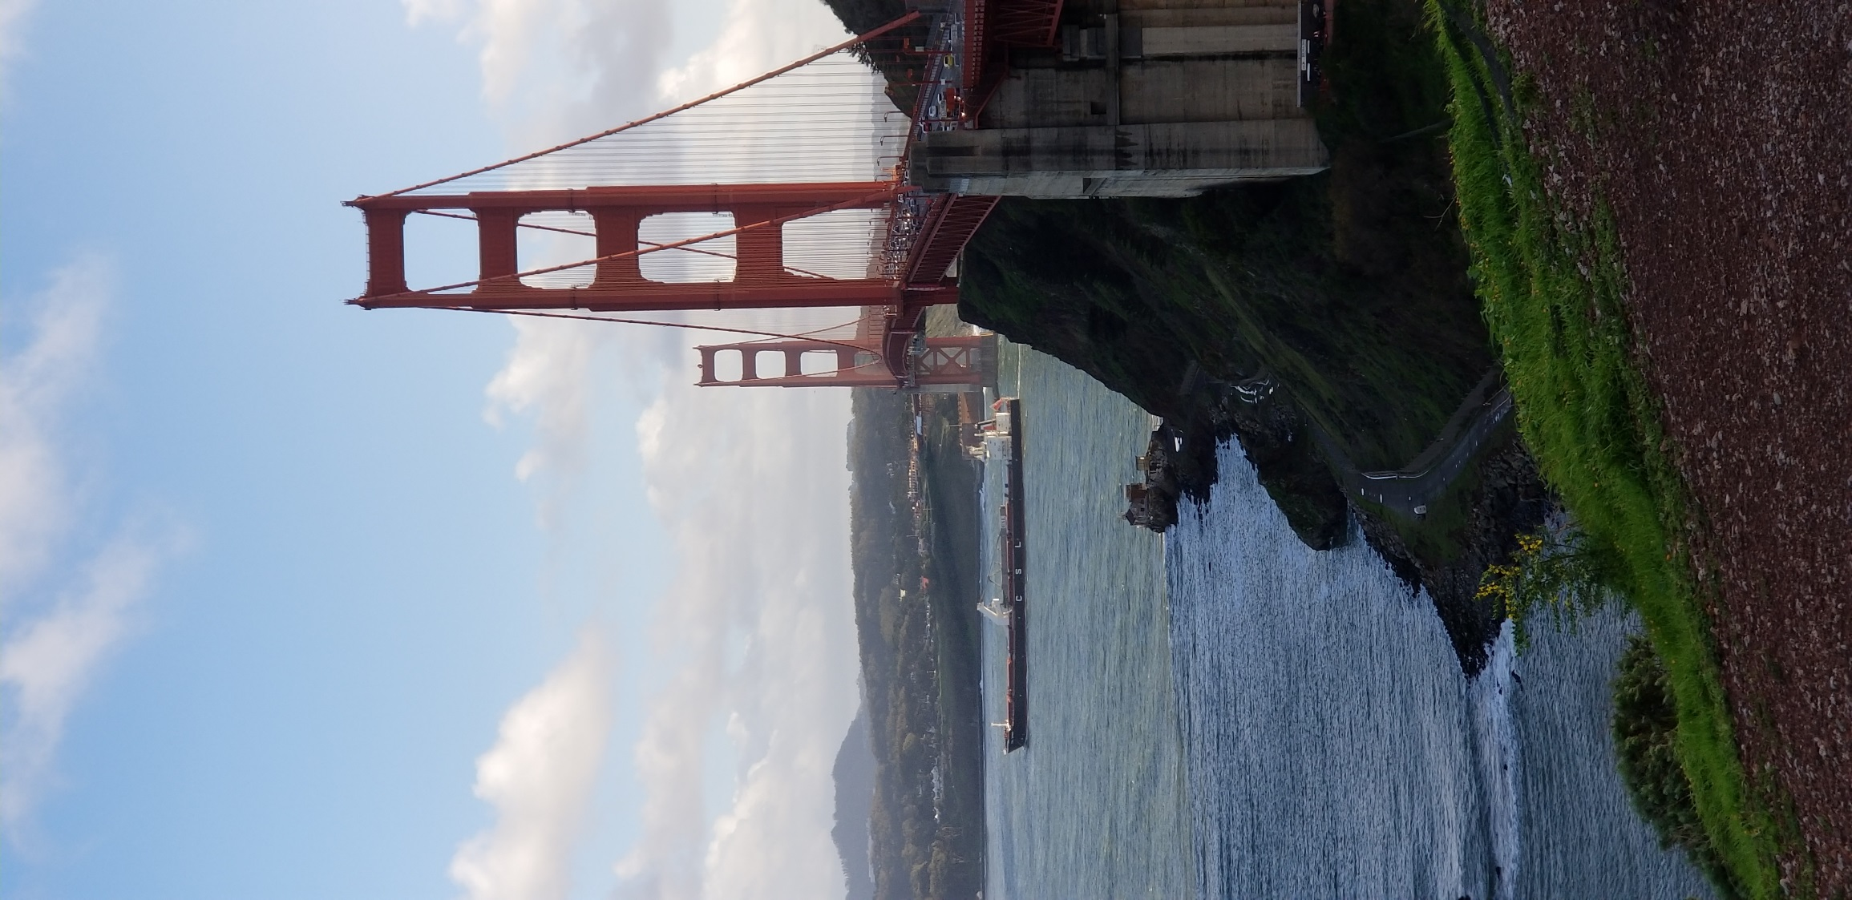

Contents
Our Why  With any problem we tackle, there should be a good reason behind why we are doing so.  The Big Idea  We have many grand ideas as to how to make this come to life, and those may morph as we go.  What’s Next  We have big plans, and here is where you will see those and their associated status. |  |  |  | What is One Bridge?  The one place for turning ideas or problems into future possibilities.  This concept is an idea to solve a pervasive problem across the business and that is – Where does a person in the business go when they have a problem or an improvement idea? Either there are many places one could go, or the place is unknown. If the distance to travel from problem to solution is too difficult, then one might just deal with the problem or snuff out the idea. This is not what we want to encourage.  Instead we want to offer ONE venue that anyone could come to with a problem or an idea, whereby we can help that problem get tackled or that idea come to fruition. Simply put, we want to help you help yourself or your team.  ~ Awais & Stacie

 |  |  | Our why  why do we want to build one bridge?  During the spring cohort of 2018 facilitated by the Innovation team, a few team members conducted a survey across many various business areas that we knew including but not limited to: Global Corporate Trust Services, USBI, Securities Processing & Vault Services, and TOS. The survey was simple. We asked these business line resources if they had a problem or an idea to improve something, like a future project, did they know how to submit that idea or who to talk to about it. The survey not only confirmed our hunch about the problem, but provided us some insightful statistics on the problem at hand.  [List starts here -]
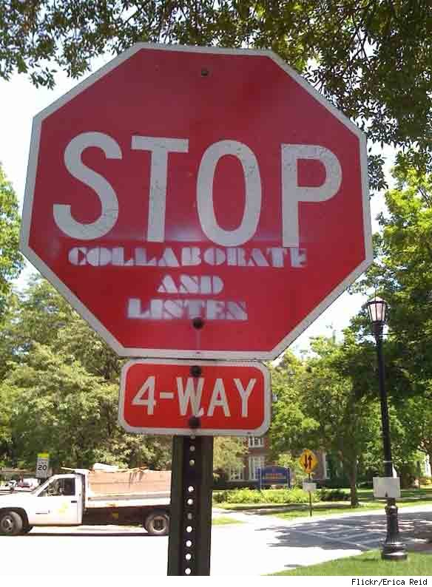[

The big idea

and so the birth of one bridge began
We thought it best to offer a kind of one stop shop whereby anyone could post a problem or throw out a solution idea that they have. Once the problem or idea was floated out there, the team behind One Bridge would review it, ask qualifying questions as needed, and then call up any other contacts for consultation purposes. Once we have had enough time to thoroughly review the problem or issue, our goal was to find out the best possible approach for resolving that problem or implementing that idea. After we had accomplished our goal, we would post a resolution to the problem or idea with the ideal approach and follow that up with a meeting with the resource(s) who would be able to take it to the next step. This meeting is crucial, because we wanted to ensure that all the knowledge we obtained was properly passed onto the resource(s) who needed it, but also that we had passed our business line requestor onto capable hands where expectations were understood.

 |  |  | what’s next  Put a new idea through one bridge  The only way to know if something will work is to give it a try, and so that is what we are planning to do. We need an idea to put through the paces and give One Bridge a try. We know there will be changes to make along the way, but are expecting that with every idea we put through One Bridge, the better the process around it will get.  Our plan is to get One Bridge setup on Idea Place, so that we can establish this as a platform and start working on the idea as we expect to. Currently, we are waiting on the Innovation team to get One Bridge setup, so that we can continue with this exercise.  Once we have One Bridge setup, we will take an idea through the process. Our first idea was something from the GCTS MABS group, but this may not be an idea that we cannot garner time from the business line area for. With that said, we may try another avenue and get an idea from GFS.
FEW POINTS TO REMEMBER ……
SCALE DoesN’t matter  a Question TO an Answer, idea to a project, all welcomed  You have a question we can get an answer for you. You may be looking for a right contact for your issues at hand, we can find it for you. You have an idea we can help you ideate it and that can become a project.  It does not matter that what are you trying to solve is just a small thing, we can be engaged so that things don’t stop and keep rolling. | 
 |  |  | Your Call when to involve us  You NEED us INVOKE us, if in right hands don’t bother  You want to connect with us because you have problems to solve or a brilliant idea to improve the way you do things. We will find the right people for you and willing to move on with you through stages as needed. Now if you are rolling on your own and conducting meetings, conference calls, and analysis & design sessions with the right people then you don’t really have to keep us involved.  We may get updates from you on and off to keep things up to date at our end as much as we can, so that in case if you ever need us again we are there to help. But we don’t want to add additional burden on you to keep us engaged all the time when it is not really necessary.
CollaboratE  Posible integration with tools like yammer to enhance collaboration.  Forming, Storming, Norming, Performing. Collaboration is the key. We will have tools like Yammer to enhance collaboration.  We will maintain a group called OneBridge in Yammer so that we can collaborate intuitively | 
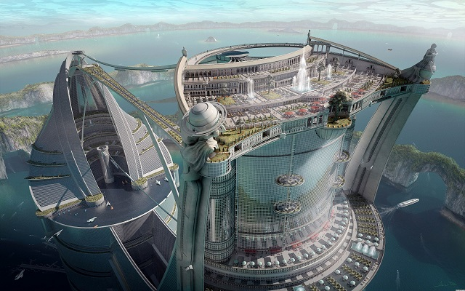 |  |  | TOS2020  A BOTTOM APPROACH: contribute yourself for TOS2020  You are attending sessions for TOS2020, you are getting these emails for TOS2020, you want to change the way you do things and so you want to contribute and you want to validate your thoughts, you can come to OneBridge.  Higher management is sending instructions to your or your team and while implementing them you have questions, you can come to One bridge.  Be it DevOps, Cloud, Automation, API, Agility, Data Consolidation…. OneBridge can be your TOS2020 bridge between you and TOS2020 champions. Who knows you can become TOS2020 champion yourself.

Other notes…

Feel free to add anything additional here -

Another TBD Section

SUBTITLE GOES HERE
Yada yada yada…

